IOT_PHASE2: PUBLIC TRANSPORT OPTIMIZATION
TEAM MEMBER: MOHAMMAD JASIR ALI(822721106305)
Project Title: Public Transport Optimization
Project Description: This project involves integrating IOT Sensors into public transportation vehicles to monitor ridership, track locations, and predict perfect arrival times. The goal is to provide real -time transit information to the public through a public platform, enhancing the efficiency and quality of public transportation services. This project includes defining Objectives, designing the IOT sensor system, developing the real-time transit information platform, and integrating them using IOT technology and python.
Designing the IOT sensor system
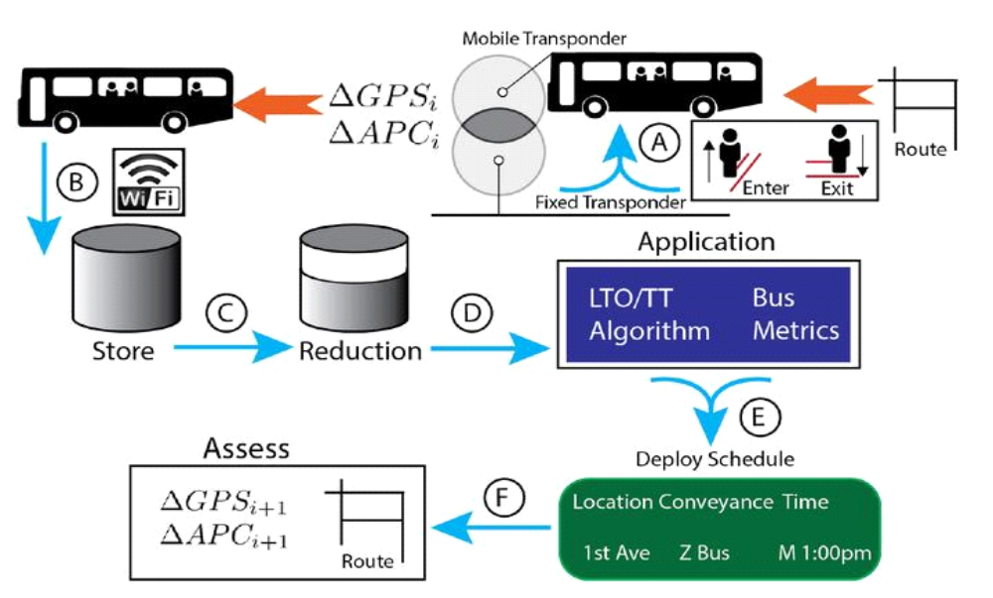
TRANSPONDER:
Transponders play a crucial role in modern public transport systems by facilitating various functions related to efficiency, safety, and convenience.
Automated Fare Collection (AFC): Transponders, often in the form of contactless smart cards or NFC-enabled mobile devices, are used for fare collection in public transport systems. Passengers can load credit onto these cards or mobile apps and tap them on card readers at entry and exit points.
Real-Time Passenger Information: Transponders can be embedded in vehicles, allowing the system to track their locations in real-time.
Security and Access Control: Transponders are used for access control in areas like depots, maintenance facilities, and restricted zones within transit stations.
Vehicle Tracking and Management: Transponders, such as GPS transponders, are used to monitor the location, speed, and performance of public transport vehicles. This data is crucial for operational management, maintenance scheduling, and optimizing routes.
Driver Identification: In some public transport systems, transponders can be used to identify drivers operating vehicles. This information is useful for tracking driver schedules, ensuring compliance with labor laws, and enhancing passenger safety.
Automated Announcements: In buses and trams, transponders can be used to trigger automated announcements at specific stops, helping passengers know where they are and which stop is next.
Traffic Management: Transponders can be used to integrate public transport vehicles into traffic management systems, reducing congestion and improving the flow of traffic on city streets.
Safety and Emergency Services: In case of emergencies or accidents, transponders can provide information about the location and status of public transport vehicles, enabling a faster and more effective response from emergency services.
Maintenance and Diagnostics: Transponders can monitor the health of vehicles and report maintenance needs in real-time, reducing downtime and improving the reliability of the system.
Environmental Impact Monitoring: Transponders can collect data on fuel consumption, emissions, and other environmental factors, which can be used for eco-friendly transit planning and to meet sustainability goals.
APC AND GPS:
APC (Automatic Passenger Counting): APC is a technology used in IoT-enabled public transportation systems to automatically count the number of passengers boarding and disembarking vehicles such as buses, trams, and trains. This data is collected through various sensors and devices, including infrared, ultrasonic, or video cameras, and is valuable for optimizing transit services, planning routes, and managing passenger loads.
GPS (Global Positioning System): GPS is a satellite-based navigation system widely used in IoT applications. It allows for precise location determination by receiving signals from a network of orbiting satellites. In IoT, GPS is used for tracking and monitoring the real-time geographic location of devices, vehicles, or assets. This information is crucial for applications like vehicle tracking, asset management, and location-based services.
Both APC and GPS are integral components of IoT solutions, especially in transportation and logistics sectors, enabling data collection and analysis for improved operational efficiency and service quality.
DATABASE:
Storing data in the cloud for public transport systems offers several advantages, including scalability, accessibility, and data analysis capabilities.
Scalability: Cloud storage solutions can easily scale up or down based on the volume of data generated by public transport systems. This scalability ensures that you can accommodate increasing data loads without the need for significant infrastructure changes.
Accessibility: Cloud storage allows data to be accessed from anywhere with an internet connection, which is particularly valuable for transportation systems with multiple locations and remote monitoring needs. This accessibility supports real-time data retrieval and analysis.
Data Integration: Cloud storage can be integrated with other cloud-based services and tools, such as data analytics platforms and IoT platforms. This integration enables data processing, analytics, and visualization, providing insights into public transport operations.
Data Security: Reputable cloud providers implement strong security measures, including data encryption and access controls, to protect data stored in the cloud. This is crucial for sensitive information, such as passenger data, payment records, and operational details.
Real-Time Data Processing: Cloud platforms can process and analyze data in real time, enabling public transport authorities to make timely decisions, optimize routes, improve operational efficiency, and enhance passenger experiences.
REDUCTON:
Reducing the size of a cloud database involves optimizing and minimizing data storage to improve performance and lower costs. Key strategies include archiving old data, compressing data, optimizing indexing, using data lifecycle policies, and leveraging cloud database management tools.
LTO ALGORITHM:
The LTO (Last Trip Optimization) algorithm in public transport is a system designed to enhance the efficiency of public transportation networks, especially during the final trips of the day. It aims to ensure that vehicles, such as buses or trams, complete their routes in a way that minimizes operational costs and maximizes passenger service. The LTO algorithm typically takes into account factors like real-time data on passenger demand, traffic conditions, and vehicle availability. By optimizing the final trips, public transport agencies can reduce operational costs, minimize delays, and improve the overall passenger experience.
TECHNOLOGY:
Integrating Python into IoT for public transport involves using the Python programming language to develop and manage IoT solutions that enhance the efficiency and effectiveness of public transportation systems.
Data Collection: Python can be used to write scripts and applications that collect data from various IoT devices, such as GPS trackers, sensors, and Automatic Passenger Counting (APC) systems, installed in public transport vehicles. This data includes information on vehicle location, passenger counts, and environmental conditions.
Data Processing: Python provides powerful data processing and analysis libraries, such as Pandas and NumPy, which can be used to clean, transform, and analyze the data collected from IoT devices. This data processing is critical for route optimization, real-time passenger information, and operational insights.
Data Visualization: Python offers libraries like Matplotlib and Seaborn to create data visualizations, charts, and graphs. These visualizations can help public transport authorities and passengers better understand the data and make informed decisions.
Real-Time Communication: Python can be used to develop real-time communication systems that send and receive data from IoT devices. This is essential for providing passengers with up-to-date information on vehicle locations and arrivals through mobile apps or information displays at transit stops.
Machine Learning and Predictive Analytics: Python's machine learning libraries, including TensorFlow and scikit-learn, can be employed to build predictive models for factors like passenger demand, maintenance needs, and route optimization. Machine learning models can help public transport systems operate more efficiently and reduce costs.
Security: Python can be used to implement security measures to protect data transmitted between IoT devices and cloud servers, ensuring the privacy and integrity of passenger and operational data.
API Integration: Python allows for easy integration with cloud services and APIs provided by IoT platforms and data storage solutions, making it a versatile tool for connecting and managing the IoT ecosystem.
Customized IoT Solutions: Python's flexibility and extensive libraries make it suitable for developing customized IoT solutions tailored to the specific needs and challenges of public transport systems.

IOT PROTOCOLS:
HTTP/HTTPS: The Hypertext Transfer Protocol (HTTP) and its secure variant, HTTPS, are widely used for web-based communication in public transport systems. They are essential for providing data to passengers via websites and mobile apps. APIs using HTTP/HTTPS can enable real-time updates, route planning, and ticket booking.
Bluetooth and Bluetooth Low Energy (BLE): Bluetooth protocols are often used for passenger interactions within public transport. BLE, in particular, enables communication with mobile devices, such as smartphones and wearables, to provide location-based services and interact with beacons at transit stops and vehicles.

